  

# Halloween ABC Grades Sprint Meet

**(Held under ASA Laws and Technical Rules)**

**Sunday, 26th October 2025**

## at Beverley Leisure Centre

**ASA Licenced Meet - Level 3**

**Times achieved will be accepted for entry to ASA area and regional competitions**

**50m sprints in all four strokes and 100m IM All events HDW**

**No A Grade cut offs**

**Age Groups: 9yrs; 10yrs; 11/12yrs; 13/14yrs; 15yrs & Over (Age on Day) Awards to top 6 in each age group & grade**

**Top Boy & Top Girl (Grade A points) in each age group Top Visiting Club Trophy**

**Session 1**

**Session 2**

Girls 9 years

Open Boys 10 years Girls 11/12 years Open Boys 13/14 years Girls 15 & Over

Open Boys 9 years

Girls 10 years Open Boys 11/12 years Girls 13/14 years Open Boys 15 & Over

**Modern eight lane 25m pool with anti-wave lane ropes and full electronic timing & scoreboard & Cafe. Parking available.**

**Entry Fees: £7.00 per individual event.**

**Entries accepted on a “First come, first served” basis through on-line entry only. Full-day Coach’s Pass, inc. meal, programme, start lists & results by web: £15**

**Spectators £5 per session, £8 all day.**

**Tickets purchased on the day First come, first served.**

**On-line Entry information available at** [**www.beverleybarracudas.com**](http://www.halloweenmeet.co.uk/)

## Closing Date: 26th September 2024 Promoter: Mr Wayne Smith

|  |  |
| --- | --- |
| Session 1 | |
| 101 | **Warm-up: 08:00 - 08:45 hrs. Start: 09:00 hrs**  **Open Boys/Girls times TBC**  Girls 9, 11/12yrs, 15yrs 4x25m Individual Medley |
| 102 | Open Boys 10 Yrs,13/14 Yrs 4x25m Individual Medley |
| 103 | Girls 9 yrs 50m Backstroke |
| 104 | Open Boys 10 Yrs 50m Breaststroke |
| 105 | Girls 11/12 yrs 50m Backstroke |
| 106 | Open Boys 13/14 Yrs 50m Freestyle |
| 107 | Girls 15yrs/O Butterfly |
| 108 | Girls 9 yrs 50m Breaststroke |
| 109 | Open Boys 10 Yrs 50m Backstroke |
| 110 | Girls 11/12 yrs 50m Breaststroke |
| 111 | Open Boys 13/14 Yrs 50m Butterfly |
| 112 | Girls 15yrs/O Freestyle |
| 113 | Girls 9 yrs 50m Freestyle |
| 114 | Open Boys 10 Yrs 50m Butterfly |
| 115 | Girls 11/12 yrs 50m Freestyle |
| 116 | Open Boys 13/14 Yrs 50m Breaststroke |
| 117 | Girls 15yrs/O Backstroke |
| 118 | Girls 9 Yrs 50m Butterfly |
| 119 | Open Boys 10 yrs 50m Freestyle |
| 120 | Girls 11/12 Yrs 50m Butterfly |
| 121 | Open Boys 13/14 yrs 50m Backstroke |
| 122 | Girls 15yrs/O Breaststroke |
| Session 2 | |
| 201 | **Warm-up: 13:00 - 13:45 hrs. Start: 14:00 hrs**  **Open Boys/Girls Times TBC**  Open Boys 9, 11/12yrs, 15yrs 4x25m Individual Medley |
| 202 | Girls 10 Yrs,13/14 Yrs 4x25m Individual Medley |
| 203 | Open Boys 9 yrs 50m Backstroke |
| 204 | Girls 10 Yrs 50m Breaststroke |
| 205 | Open Boys 11/12 yrs 50m Backstroke |
| 206 | Girls 13/14 Yrs 50m Freestyle |
| 207 | Open Boys 15yrs/O Butterfly |
| 208 | Open Boys 9 yrs 50m Breaststroke |
| 209 | Girls 10 Yrs 50m Backstroke |
| 210 | Open Boys 11/12 yrs 50m Breaststroke |
| 211 | Girls 13/14 Yrs 50m Butterfly |
| 212 | Open Boys 15yrs/O Freestyle |
| 213 | Open Boys 9 yrs 50m Freestyle |
| 214 | Girls 10 Yrs 50m Butterfly |
| 215 | Open Boys 11/12 yrs 50m Freestyle |
| 216 | Girls 13/14 Yrs 50m Breaststroke |
| 217 | Open Boys 15yrs/O Backstroke |
| 218 | Open Boys 9 Yrs 50m Butterfly |
| 219 | Girls 10 yrs 50m Freestyle |
| 220 | Open Boys 11/12 Yrs 50m Butterfly |
| 221 | Girls 13/14 yrs 50m Backstroke |
| 222 | Open Boys 15yrs/O Breaststroke |

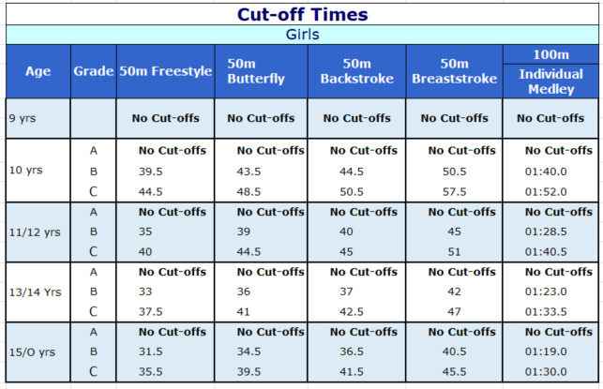

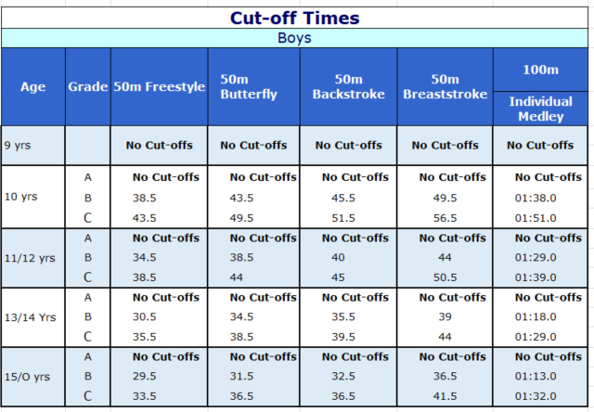

Meet Conditions

1. The promoter for this event is Mr Wayne Smith
2. The Competition will be held Under ASA Law & Technical Rules.
3. Over the top starts may be used at the Lead Referee's discretion. Swimmers are requested to remain in the water until ask to leave the pool.
4. The one start rule will apply.
5. There is no secondary strobe at this event.
6. All events are heat declared winners.
7. The Referee’s decision is final.
8. The pool is 25m long, 8 lanes with anti-wave ropes and electronic timing.
9. Age groups are: boys and girls 9yrs, 10yrs, 11-12yrs, 13-14yrs and 15yrs and over.
10. Ages are as at midnight 26th October 2025
11. Entries must be made via the online entry system at [www.openmeets.co.uk.](http://www.openmeets.co.uk/) No other entries will be accepted.
12. Poolside entries may be accepted at the discretion of the Entries Manager.
13. Entry times are based on 25m pool times or converted 50m pool times by use of the ASA Conversion tables
14. The Female category is for birth sex females in accordance with Swim England’s Transgender and Non-Binary Competition Policy. By entering the ‘Female’ category, a swimmer confirms that their birth sex is female.
15. The closing date for entries is the 26th September 2025 or when the meet is declared full - whichever is earliest and refers to the final date on which entries must be submitted through the on line entry system.
16. Entries are accepted on the 'first come, first served' basis. Should the entries be oversubscribed, the Promoter reserves the right to limit entries by rejection of the last entries received.
17. This meet will operate as a cardless meet. Check in sheets for each club are provided in the coach’s pack and must be completed and returned to the technical team by the deadline, which will be announced on the day.
18. The fees for this event are £7 per swim, Minimum 2 swims per swimmer. Withdrawals will not be refunded, except for withdrawals necessary on medical grounds. Entries may be refused if payment is not made by the date of the gala.
19. Medals will be awarded for each event to the first six, in each gender, age group and grade. All awards can be collected from the medals table during the course of the meet.
20. In each event and grade points will be awarded to the top six (6, 5, 4, 3, 2 and 1). Points will be totalled for top boy, top girl and overall top club based on Grade A points If there is a tie on points awards will be given to the swimmer/club with the most first places..
21. Swimmers must report to marshalling at least one event prior to their event.
22. Swimmers leaving poolside should be clothed, with appropriate footwear and should not enter the spectator gallery without a spectator ticket.
23. Coach’s passes are priced at £15 and include a programme, start sheets, buffet lunch and full access to results through our website which will be published on the day of the meet.
24. Coaches MUST wear wristbands provided whilst on poolside. Only swimmers with accepted entries for the session in progress and Coaches/Team Managers with a valid pass will be allowed on poolside. Each team will have a designated poolside area.
25. Coaches/Team Managers are wholly responsible for the conduct of their swimmers during the meet, including warm ups. Coaches/Team Managers are requested to ensure their swimmers respect the officials and are silent at the start of each event.
26. Admission for spectators will be £5 per session, £8 all day. Programmes will be sold on the day for £3. No entry will be allowed onto the spectator area without a wristband. The spectator area will be cleared between sessions.
27. Any Point not covered by the above will be at the discretion of the promoter and lead referee.

